IKG Chatbot
Oct 8, 2026 · @Pratik

What it does
You type a question the way you would ask a colleague: "Which households have more than $100M and what are their accounts worth?" The chatbot works out which of the 56 profile tables and which columns hold the answer, writes the database query, runs it, and replies with the answer, the table of rows, the query it used and the assumptions it made. It only reads data, it only reads the *_profile_curr_ikg_v2 tables, and every number in its reply comes from the query result — not from the model's memory.
It understands the data the way project 1 documented it: the business description of every column, the glossary of abbreviations, the joining keys between households, clients and accounts, and the business rules in the skill files (for example that household means the statement household, acc_mhh_n). When a question leaves something open — "x%", "my clients", "upcoming" — it asks one short question instead of guessing.

How a question becomes an answer
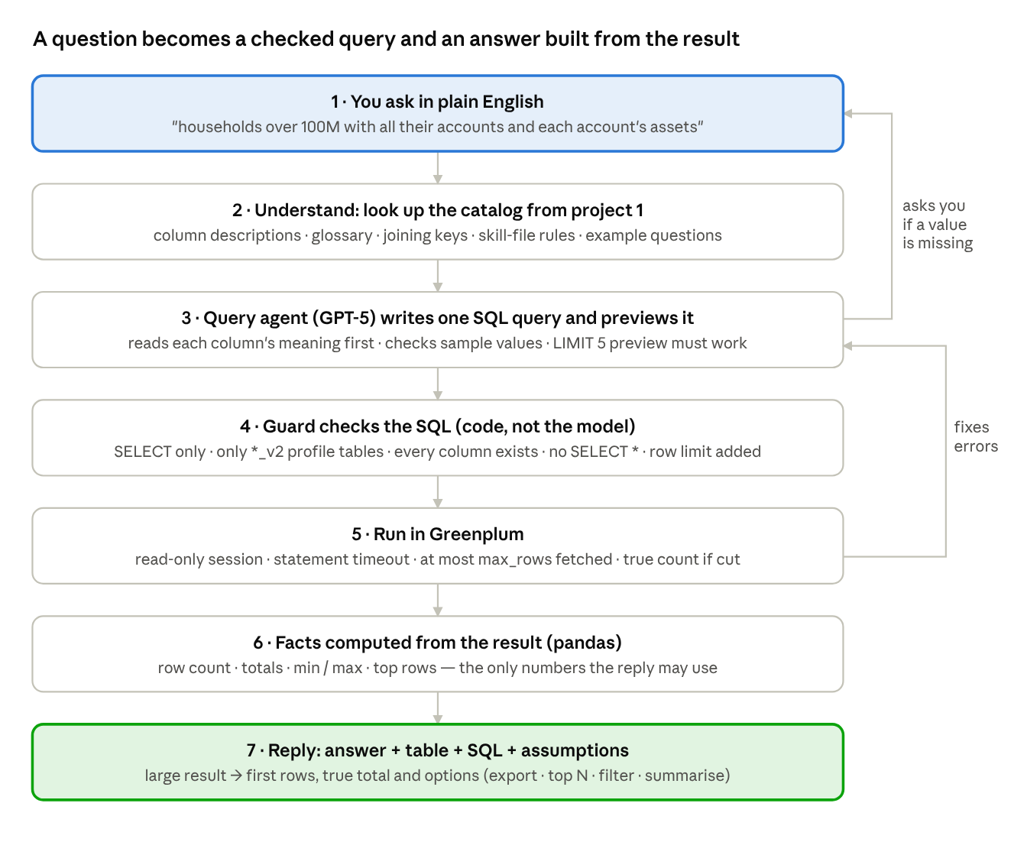
question to answer · 7 steps, 2 loops
The model does two things only: it chooses the data and writes the query (step 3), and it words the reply (step 7). Everything in between — the safety checks, the execution and the numbers — is ordinary code, which is what makes the answers repeatable and checkable.

Worked example
You: give me households with assets greater than 100M and provide all related accounts and the asset value of each account
What happens underneath
- The catalog search matches the concepts household, assets and account. The agent reads the descriptions of mhh_assets_curr (household total assets, USD) in household_profile_curr_ikg_v2 and acc_assets_curr (account total assets) in account_profile_curr_ikg_v2, and asks the knowledge graph how the two join: acc_mhh_n.
- It writes one query — household id and total, joined to its accounts with each account's assets, filtered on mhh_assets_curr > 100000000, largest household first — and previews five rows to make sure it runs and the values look like dollars.
- The guard confirms every column exists, both tables are _v2 clones and adds the row limit; Greenplum runs it.
- Code counts the rows and computes the totals; the answer agent words the reply from those facts.
Bot: There are 44 account rows across 12 statement households with more than $100M in total assets. The largest household holds $498.5M; the table lists each household's total and every account with its own assets, largest first. Assumptions: household = statement household (acc_mhh_n); "100M" read as $100,000,000; assets = current total assets in UBS accounts. — followed by the table, the SQL, and the suggestion "break it down by advisor".
(The numbers are from the self-test's synthetic data; the real figures come from your Greenplum.)

What keeps the answers accurate
- Meaning before name. The agent must read a column's business description (from project 1) before using it; a column name is only a hint. That is how it knows acc_mhh_n is the statement household and that a "count of credit cards" counts accounts.
- Nothing is guessed. Missing values ("x%", "$x", "in the next x days", "my clients") trigger one clarifying question with suggested defaults. Scale is checked before a threshold is applied (a percent column may be 0–1 or 0–100).
- The query is proven before it is trusted. A five-row preview must succeed; then the guard parses the SQL and rejects anything that is not a single SELECT on the _v2 tables with existing columns. Database errors go back to the agent for at most two repairs.
- Numbers come from the data. Totals, counts and extremes are computed in code; the reply may only quote those. A reply containing a number that is not in the facts is sent back.
- Everything is shown. The SQL, the assumptions and the caveats are part of every answer, so a reviewer can rerun or challenge it. Each turn is logged to output/chat_history.jsonl.
- Read-only by construction. The database session is opened read-only with a statement timeout; the guard refuses INSERT/UPDATE/DELETE/DDL and any table outside the allowed list.

Large results and follow-ups
When a question matches thousands of rows the bot does not dump them. It fetches up to max_rows (2,000 by default), runs a count for the true total, shows the first preview_rows (10) and offers four options — you answer with the number or in words:
Option | What the bot does
(1) export the full result to a CSV file | re-runs the query without the preview limit (up to export_max_rows) and writes output/exports/<question>_<timestamp>.csv
(2) show the top N rows sorted by a column | asks how many and by which column, then re-queries
(3) add a filter | asks which filter (FA, region, minimum amount) and re-queries
(4) summarise instead | counts and totals grouped by the most useful dimension
Other follow-ups: next pages through the result, show sql repeats the query, and any new question that refers to the previous one ("only for FA 12", "the same for clients") is answered with the last query in context.
Questions about the data itself ("what does acc_mhh_n mean?", "which tables have cash columns?") are answered from the catalog without running SQL.

What it needs
Source | Where | Needed | Used for
*_profile_curr_ikg_v2 clone tables (project 1) | Greenplum core_ikg | yes | the only tables the bot queries
ikg_attribute_business_description | Greenplum | yes | meaning of every column
ikg_graph_joining_key, ikg_graph_relationship | Greenplum | recommended | how tables join
ikg_metadata_glossary_llm | Greenplum | recommended | abbreviations in questions and names
ikg_profile_table_descriptions | Greenplum | recommended | table grain and purpose
information_schema of the _v2 tables | Greenplum | yes | real columns and types for the guard
GitLab ikg-dags @ main, ikg_create_profiles SQL | GitLab | optional | how a column is derived
config/entity_model.yaml, concepts.yaml, question_bank.yaml, skills/*.md | files in the package | yes | entities and keys, business synonyms, example questions, rules
Azure OpenAI gpt-5-pshah | Azure | yes | query agent and answer agent
Secrets — Azure key, Greenplum password, GitLab token — are typed at runtime or read from environment variables; nothing is stored in the config or the code. python run_chatbot.py --check reports which of these sources are present.

How to run it and make it better
- python run_chatbot.py --selftest — offline proof that the whole chain works (synthetic data, scripted model, 12 checks).
- python run_chatbot.py --check — Greenplum, Azure OpenAI and GitLab connectivity; lists the sources found.
- Open IKG_Chatbot.ipynb (or python run_chatbot.py for a terminal chat, streamlit run app_streamlit.py for a web page). The first run builds output/catalog.json from the project-1 tables; rebuild it after project 1 is re-run.
When an answer is not what you expected, the fix is almost always in a file a business user can edit:
- the bot picked the wrong column → sharpen that column's description in project 1's metadata table and rebuild the catalog;
- it did not understand a business term → add the term and the column words it maps to in config/concepts.yaml;
- a rule it must always follow (what household means, which FA key to use) → write it in skills/chatbot_query_rules.md;
- a recurring question → add it with hints to config/question_bank.yaml, and the agent will see it as an example.
All thresholds — preview size, row caps, timeouts, repair rounds, whether the SQL is shown — live in config/chatbot_config.yaml.

